**Single Linked List**

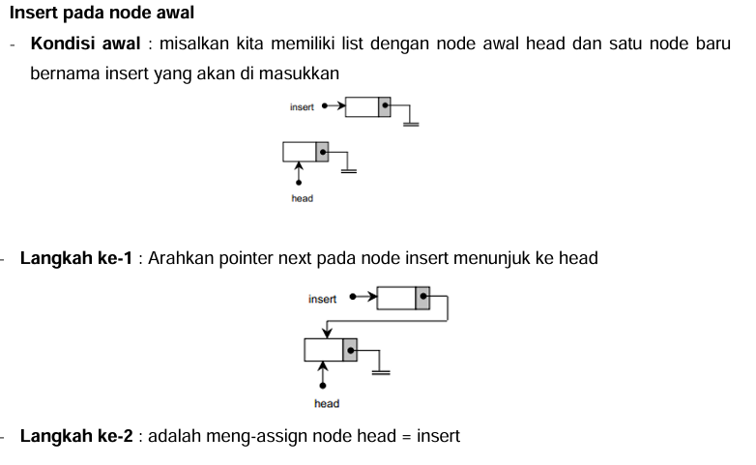

Kode Program :

 //insert di awal node

    insert = new node;

    insert->data = 5;

    insert->next = head;

    head = insert;

    cout<<"Data insert di awal : ";

    tampil();

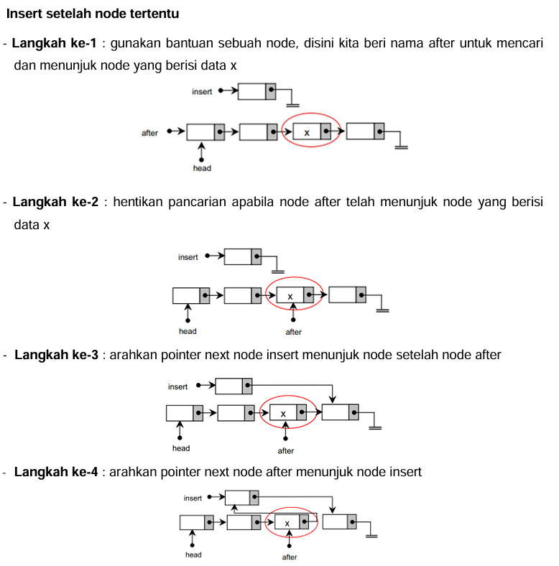

Kode Program :

//insert setelah node tertentu (x)

    x = 11;

    insert = new node;

    insert->data=35;

    insert->next=NULL;

    node *after;

    after = head;

    while (after->data != x && after->next != NULL){

        after = after->next;

    }

    if(after->data == x){

        insert->next=after->next;

        after->next = insert;

    }else{

        cout<<"Data tidak ditemukan"<<endl;

    }

    cout<<"Data setelah insert setelah 10 : ";

    tampil();

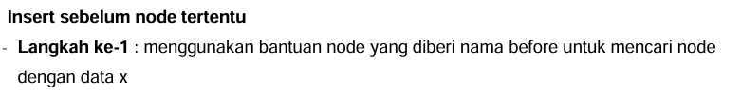

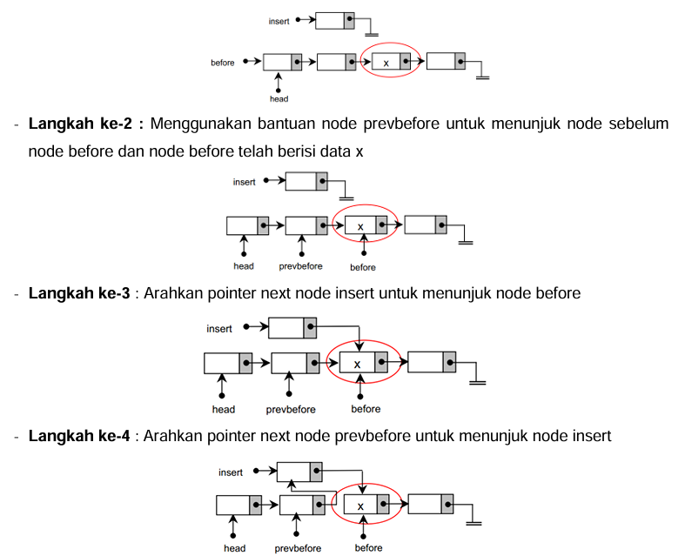

Kode Program :

 //insert sebelum node tertentu

    x = 20;

    insert = new node;

    insert->data = 15;

    insert->next = NULL;

    //jika disisipkan di depan head

    if(head != NULL && head->data==x){

        insert->next = head;

        head = insert;

    } else {

        node *prev = head;

        while (prev->next != NULL && prev->next->data != x){

            prev = prev->next;

        }

        if(prev->next != NULL){

            insert->next = prev->next;

            prev->next = insert ;

        }else{

            cout<<"data tidak ditemukan"<<endl;

        }

    }

    cout<<"Data setelah insert sebelum 20 : ";

    tampil();

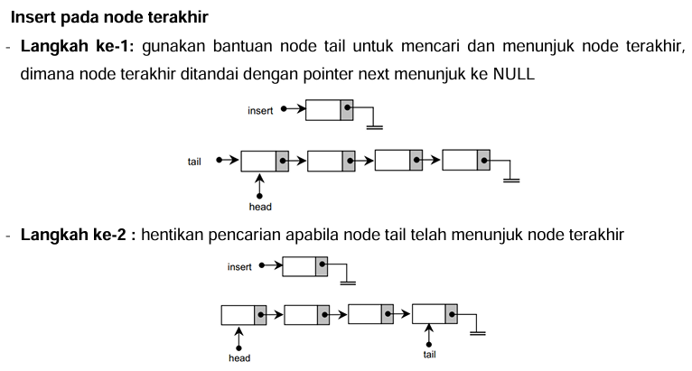

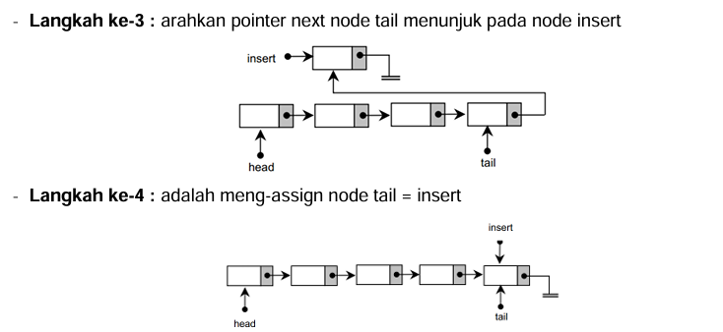

Kode Program :

 //insert di akhir node

    insert = new node;

    insert->data = 50;

    insert->next = NULL;

    node *tail = head;

    while(tail->next != NULL){ //mencari next terakhir yaitu null

        tail = tail->next;

    }

    tail->next = insert; //lalu tail -> next = null diganti dengan insert, supaya next ke node insert

    cout<<"Data insert di akhir : ";

    tampil();